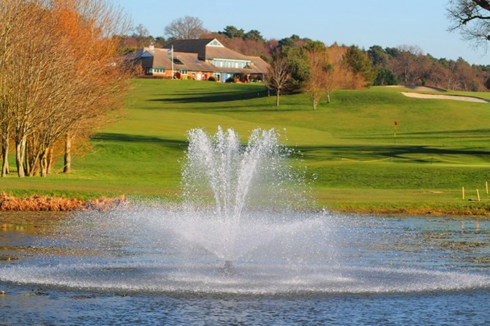Team entry into our 4-ball is **£240** and includes:

**Dudsbury Golf Club**

64 Christchurch Road, Ferndown, Dorset BH22 8ST

**Annual Charity Golf Day**

**on Friday 14th August 2020**

* + - * A coffee/tea & bacon bap on arrival
      * 18 holes
      * Two-Tee Start, from 09:00am
      * Prizes for 1st, 2nd, 3rd place winners
      * Nearest the pin & longest Drive competition
      * ‘Bin of Booze’ competition
      * 2-course late lunch afterwards
      * Raffle and Auction

|  |
| --- |
| Team Name: |
| Captain: | Club: | H/cap: |
| Partner 1: | Club: | H/cap: |
| Partner 2: | Club: | H/cap: |
| Partner 3: | Club: | H/cap: |

I enclose a cheque for **£240** made payable to ‘Round Table Children’s Wish’ & posted to address below 

or

I have made a payment by BACS of **£240** using the bank details below 

Our bank details are as follows: NatWest, Round Table Children’s Wish Account no. 56256620

Sort Code 52-21-34.

Please put **‘Golf Day’** as a reference on the payment, so we know what this relates to when it comes through.

|  |
| --- |
| Captain’s address: |
|  |
|  |
|  |
| Tel no: |
| Email address: |

|  |  |
| --- | --- |
| Preferred tee time: | Please circle one: /early / late / no preference |

**Data protection:**

As a valued supporter of RTCW, we’d love to keep in contact with you about future golf days and events, but we need your permission first! Please tick the box if you’d like to receive emails from us (You can of course choose to stop receiving these at any time)

**Photograph / Video Content:**

Please tick the box if you, and your team grant full rights for Round Table Children’s Wish to use the images resulting from the photography/video filming on the Golf Day Event in 2020. This might include (but is not limited to), the right to use them in RTCW printed and, or online publications, such as the website, Facebook, Twitter, Instagram, press releases and funding applications. 